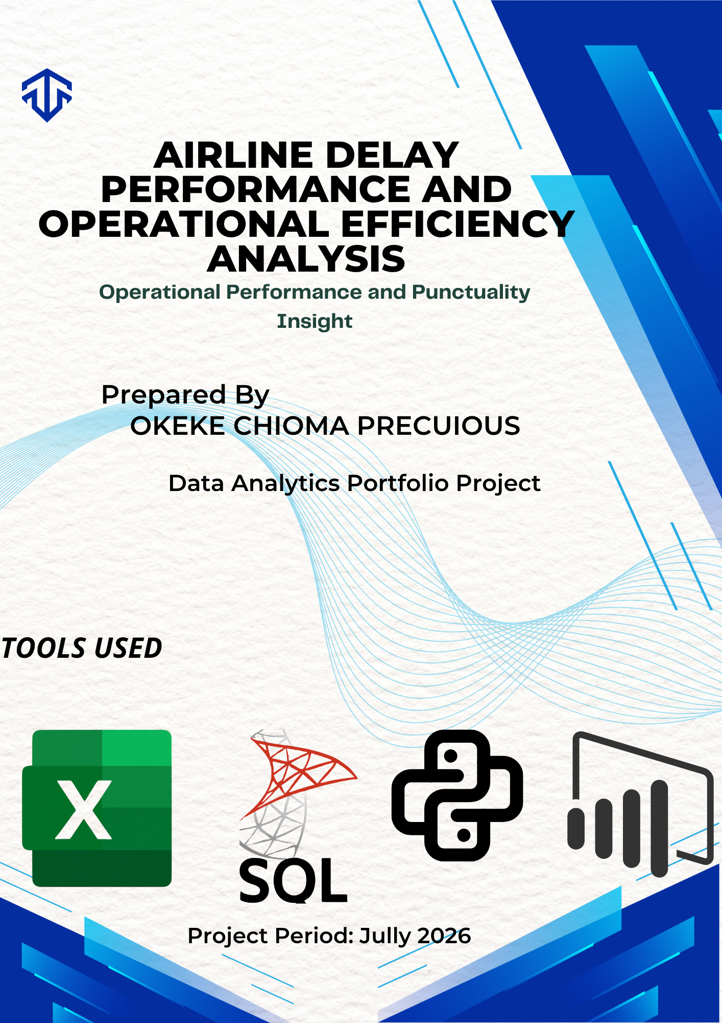

TABLE OF CONTENTS
Contents
TABLE OF CONTENTS 2
EXECUTIVE SUMMARY 3
INTRODUCTION 3
PROJECT OBJECTIVES 3
DATASET DESCRIPTION 4
METHODOLOGY 4
RESULTS AND FINDINGS 5
DASHBOARD 8
KEY BUSINESS INSIGHTS 9
CONCLUSION 9
TOOLS USED 9
SKILLS DEMONSTRATED 9
REFERENCE 10

EXECUTIVE SUMMARY

This project analyzes 15,000 airline flight records to evaluate airline operational performance, identify delay patterns, and provide actionable business insights. The analysis was completed using Microsoft Excel for data preparation, SQL Server for querying and analysis, Python for data validation and visualization, and Power BI for dashboard development.
The project focused on answering five business questions related to airline performance, flight delays, and operational efficiency. The findings provide valuable insights that can support better scheduling, and enhance operational performance.

INTRODUCTION
The airline industry relies heavily on operational efficiency and punctuality to deliver high-quality services. Flight delays can negatively affect customer satisfaction, increase operating costs and disrupt airline schedules.
This project aims to analyze airline delay data to identify trends, evaluate airline performance and provide recommendations that support data-driven operational decisions.

PROJECT OBJECTIVES
The objectives of this project are to answer the following business question:
- Which airline performs better?
- Does flight distance affect delays?
- Which flight successfully recovered delays?
- Which flights are operationally inefficient?
- Which airline struggles most with punctuality?

DATASET DESCRIPTION
The dataset contains 15,000 airline flight records.
Variables Used
- Flight ID
- Airline
- Distance (Km)
- Distance Category
- Departure Delay (minutes)
- Arrival Delay (minutes)
- Delay Difference
- Delay Status

METHODOLOGY
Microsoft Excel
- Imported and reviewed the dataset.
- Cleaned and organized the data.
- Created calculated columns such as Distance Category and Delay Difference.
- Prepared the dataset for further analysis.
SQL Server
- Imported the cleaned dataset.
- Performed data analysis using SQL queries.
- Calculated average arrival delays.
- Identified delayed flights.
- Measured airline performance.
- Analyzed operational inefficiencies.

Python (Pandas & Matplotlib)
- Imported the dataset.
- Validated SQL analysis results.
- Performed exploratory data analysis.
- Created visualizations to support the findings.
Power BI
- Developed an interactive dashboard.
- Created KPI cards.
- Built bar charts and tables.
- Added slicers for Airlines, Distance Category and Delay Status.
- Designed a professional dashboard for business reporting.

RESULTS AND FINDINGS
Objective 1: Which Airline Performs Better?
Findings
Delta recorded the strongest operational performance by maintaining the lowest average arrival delay among the airlines analyzed. Lufthansa followed closely, while Emirates and indigo experienced relatively higher average arrival delays.
Business Impact
Lower arrival delays improve customer satisfaction, reduce operational costs and strengthen airline reputation.
Recommendation
Although the overall performance of all airlines was relatively strong, airlines with lower on-time performance should focus on enhancing operational efficiency through improved flight scheduling, proactive aircraft maintenance and better coordination of ground operations. Leveraging predictive analytics to identify potential disruptions, optimize resource allocation and improve crew scheduling can further reduce punctuality. By implementing these measures, airlines can improve service reliability, strengthen customer satisfaction and achieve higher levels of operational performance.

Objective 2: Does Flight Distance Affect Delays?
Findings
The analysis revealed that average arrival delays were similar across short-haul, medium-haul and long-haul flights. Flight distance had little influence on arrival delays.
Business Impact
Operational inefficiencies, airport congestion and scheduling issues have a greater effect on delays than travel distance.
Recommendation
Since delays appear to be relatively consistent across all distance categories, all airlines should on addressing operational factors that are more likely to influence punctuality. These include improving flight scheduling aircraft maintenance programs, and leveraging data analytics to anticipate and manage potential disruptions. By strengthening these areas, airlines can improve on-time performance and operational efficiency across both short-haul and long-haul touts.

Objective 3: Which Flights Successfully Recovered Delays?
Findings
Several flights departed late but arrived earlier than expected, resulting in a negative Delay Difference. These flights demonstrated successful delay recovery.
Business Impact
Effective delay recovery improves customer satisfaction and strengthens overall service reliability. Flights that effectively recover delays demonstrate operational resilience and providing valuable insights for improving network-wide performance.
Recommendation
Airlines should study the operational practices of these flights and apply similar strategies where safe and appropriate. This includes optimizing flight routes, leveraging favorable flight conditions and enhancing operational decision-making. By identifying and replicating the factors that enable delays, improve arrival punctuality and enhance overall operational efficiency.

Objective 4: Which Flights Were Operationally Inefficient?
Findings
Flights with arrival delays greater than 120 minutes were classified as operationally inefficient. These flights experienced significant delays that affected operational performance.
Business Impact
Severe delays increase operational costs, passenger dissatisfaction and damage to airline reputation.
Recommendation
Airlines should investigate the root causes of severe delays, improve maintenance planning, optimize crew scheduling and strengthen contingency plans. Additionally, implementing predictive analytics can help identify potential disruptions before they occur, enabling proactive decision-making and minimizing severe delays.

Objective 5: Which Airlines Struggle with Punctuality?
Findings
Emirates recorded the highest number of delayed flights, followed by Indigo, Delta and Lufthansa.
Business Impact
High delay frequencies reduce customer confidence, increase compensation costs and negatively affect operational performance.

Recommendation
Airlines with high delay frequencies should improve departure scheduling, optimize turnaround times and continuously monitor delay trends using interactive dashboards. Additionally, improving crew scheduling and resource allocation can help minimize operational delay.

DASHBOARD
Airline Delay Performance
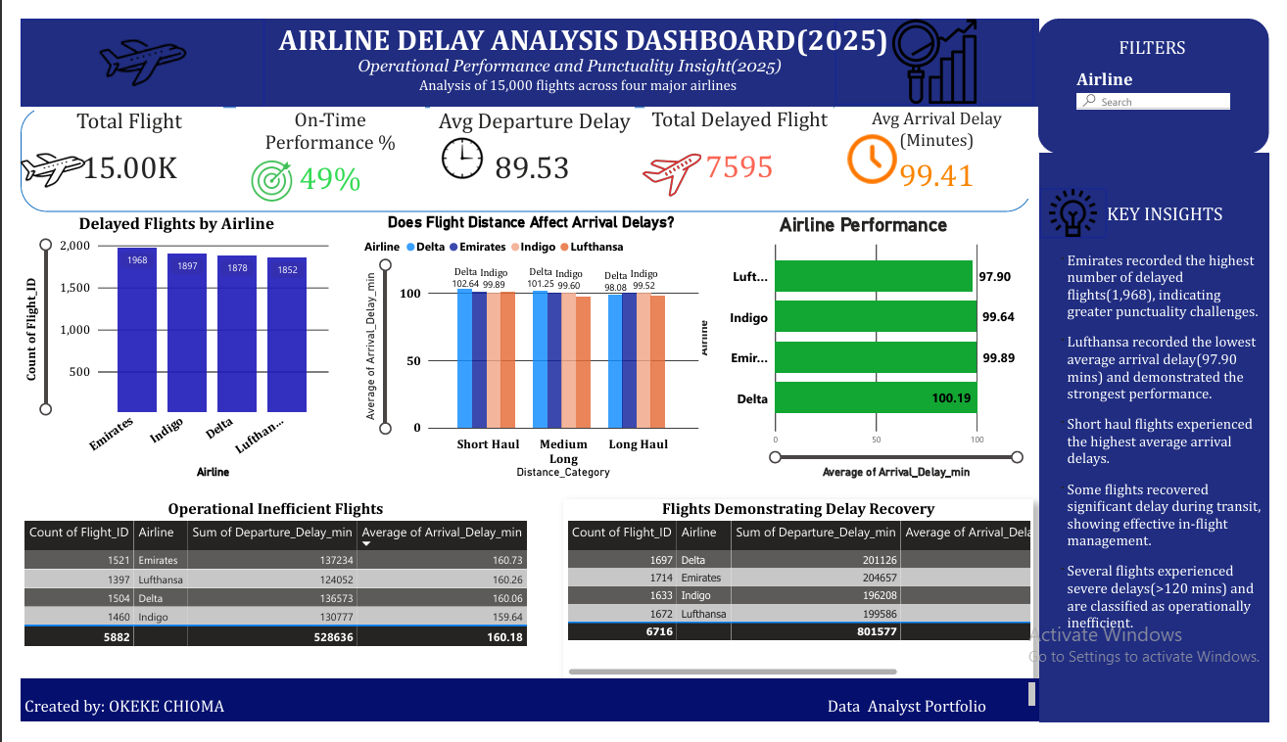
Power BI Dashboard Showing Airline Delay Performance and Operational Efficiency Analysis.

The Power BI dashboard provides an interactive overview of airline performance through KPI cards, charts, tables and slicers. User can analysis arrivals, airline performance, operational efficiencies and delay recovery using interactive filters.

KEY BUSINESS INSIGHTS
- Delta demonstrated the strongest overall operational performance.
- Flight distance had minimal impact on arrival delays.
- Delay recovery is achievable through efficient operational planning.
- Operational inefficiencies remain a significant contributor to severe delays.
- Airlines with higher delay frequencies should prioritize operational improvements to enhance punctuality and customer satisfaction.

CONCLUSION
This project demonstrates how data analytics can transform raw operational data into meaningful business insights. By integrating Microsoft Excel, SQL Server, Python and Power BI, the analysis identified performance trends, operational bottlenecks and opportunities for improvement.
The insights generated from this project support data-driven decision-making that can improve airline efficiency, reduce delays, enhance customer satisfaction and strengthen overall operational performance.

TOOLS USED
- Microsoft Excel
- SQL Server
- Python (Pandas & Matplotlib)
- Power BI

SKILLS DEMONSTRATED
Technical Skills
- Data Cleaning
- SQL Querying
- Python Programming
- Data Visualization
- Dashboard Development
- Business Intelligence
Analytical Skills
- Exploratory Data Analysis (EDA)
- Business Insight Generation
- KPI Development
- Data Storytelling
- Business Recommendation Development
- Decision Support Analytics

REFERENCE
- Airline Delay Dataset (include the source if applicable such as Kaggle or another provider).
- Microsoft Power BI Documentation.
- Python (Pandas & Matplotlib) Documentation.
- Microsoft SQL Server Documentation.

